EXPERIMENT-1
ROLL NO: 240701556 Name: Tarun Antony M

USER INTERFACE AND DESIGN
COMAPARSION OF UI DESIGN BETWEEN TWO FIGMA CREATION
Bad website:
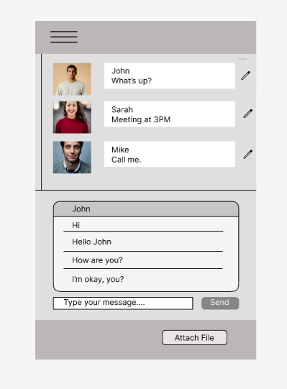

Good website:
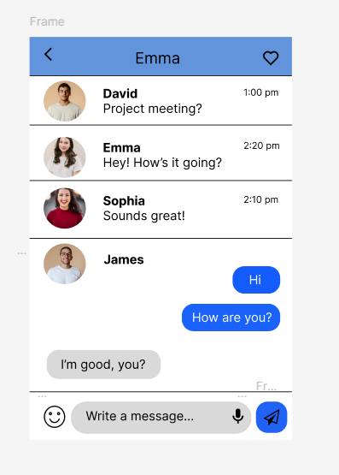
Prototype:

BAD WEBSITE / OLD UI – Old Messaging App
1. Design Style
- Uses a basic and outdated layout.
- Lacks proper spacing and alignment between elements.
- Uses dull colors with poor visual hierarchy.
- Chat interface appears cluttered and less attractive.
2. Content & Features
- Displays only plain text messages.
- No support for emojis, reactions, or voice messages.
- Message bubbles are not clearly differentiated between sender and receiver.
3. Navigation & Controls
- Limited navigation options.
- Uses basic text buttons instead of intuitive icons.
- Absence of modern features like edit profile or quick actions.
4. User Experience Drawbacks
- Difficult to identify active chats.
- No visual feedback for interactions.
- Overall interface feels less engaging and inefficient.

GOOD WEBSITE / NEW UI – Modern Messaging App
1. Design Style
- Uses a clean, modern, and visually appealing layout.
- Proper spacing, alignment, and rounded elements improve readability.
- Consistent color scheme enhances the overall look and feel.
2. Content & Features
- Supports emoji reactions, voice messages, and icons.
- Clearly differentiated chat bubbles for sender and receiver.
- Profile images improve user recognition and personalization.
3. Navigation & Controls
- Icon-based navigation such as menu, heart, mic, and send icons.
- Rounded message input box with placeholder text.
- Quick and intuitive controls enhance usability.
4. User Experience Improvements
- Better interaction through emojis and voice messages.
- Improved readability and visual clarity.
- Engaging interface that encourages continuous conversation.
Key Differences
- Visual Design:
Old UI is cluttered and outdated, while the new UI is clean and modern.
- Features:
Old UI lacks interactive elements; the new UI includes emojis, icons, and voice messaging.
- Usability:
New UI is more intuitive and user-friendly compared to the old UI.
- User Engagement:
Modern UI improves communication experience and user satisfaction.

